Reference = non.sclerotic (baseline)

#using non.sclerotic as referenc too, so sclerotic vs non.sclerotic and modele **~group**

Sclerotic compared to reference (sclerotic vs non.sclerotic) **~patient + group**

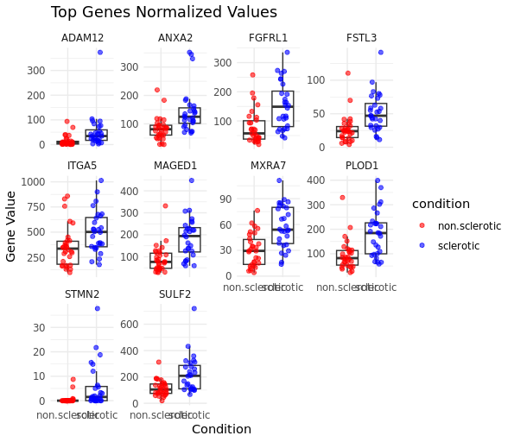

#using non.sclerotic as referenc too, so sclerotic vs non.sclerotic and modele **~batch + group**

